Construction |  Mining | Training  Business | Hospitality | Theatre and Creative Arts| Information and Communications Technology | To the Finance Manager,  Dear Sir,  Please find details of banking and other information for  Halo Nation Training Pty Ltd  ACN 133 724 660  ABN 87 133 724 660  Banking Details:  Bank Details: Bank of Qld  BSB: 124-327  Ac No: 2197 4063  Name: Halo Nation Training Pty Ltd  Contact Details:  Evelyn Byrne  Compliance and Administration  1300 HALONT (425 668)  Mb: 0423 400 171  Regards  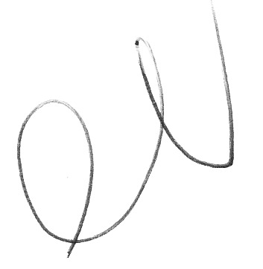  Phil Statham  Operations and Compliance Manager  Halo Nation Training Pty Ltd  27 May 2016
General Enquires
info@halont.edu.au

12 Barrington Cres
WAKERLEY
QLD 4154

PO Box 2989
MC BURLEIGH HEADS
QLD 4220

Halo Nation Training
Pty Ltd
Provider No: 32485

ACN 133 724 660
ABN 87 133 724 660

